# Using # to select an element with a specified id

In CSS Selector, we can use **#** to locate the elements by id.  
  
**Examples:**  
  
**p#para1**  -> Locates the paragraph element which has the id value as 'para1'  
**#para1** -> Locates all the elements which has the id value as 'para1'

View the page source and identify the id attribute value of the paragraph text element that we want to locate using CSS path as shown below:

[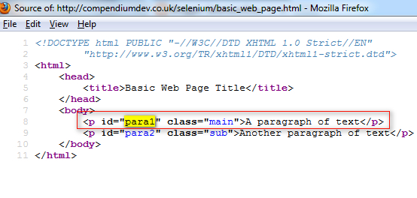](http://4.bp.blogspot.com/-LsoaYBEMfGo/UXjPRlJ9GII/AAAAAAAAR70/5dThCnvG4bg/s1600/2.jpg)

Click on the 'Firepath' tab, select the CSS option, enter the CSS path **p#para1** into the text box as shown below and click on 'Eval' button:

[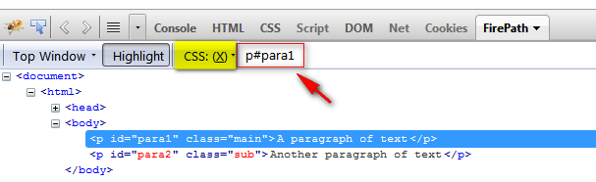](http://3.bp.blogspot.com/-CJkqfrmUZ7k/UXjPzQ-dUhI/AAAAAAAAR78/C0fl6Atwm1Q/s1600/3.jpg)

Now lets locate the element which contains the id value specified as 'para1' using CSS

[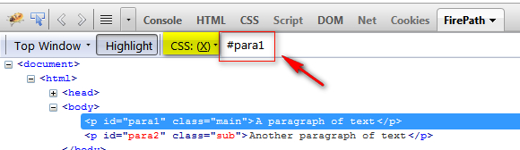](http://1.bp.blogspot.com/-vEWDxvBIRec/UXjRkRaQyTI/AAAAAAAAR8Y/gj-y-pbSpU8/s1600/5.jpg)

# Assert True

**assertTrue( _driver.findElement(By.id("q")).isDisplayed( ) );**for verifying whether the Text Box field is present on the page as shown below:

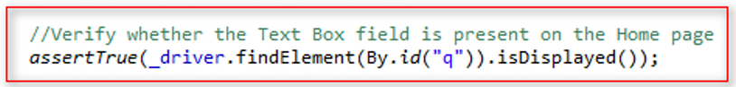

# isSelected



# Close

**close( )** WebDriver command closes the Browser window which is in focus.  
  
If there are more than one Browser window opened by the Selenium Automation, then the close( ) command will only close the Browser window which is having focus at that time. It wont close the remaining Browser windows.

# Quit Where as **quit( )** WebDriver command is generally used to shut down the WebDrivers instance. Hence it closes all the Browser windows that are opened by the Selenium Automation. **close( )** and **quit( )** work in the similar way when Selenium Automation opens only single Browser window. They differ in their functionality when there are more than one Browser windows opened by the Selenium Automation.

# SendkeysToEnterMultipleLines

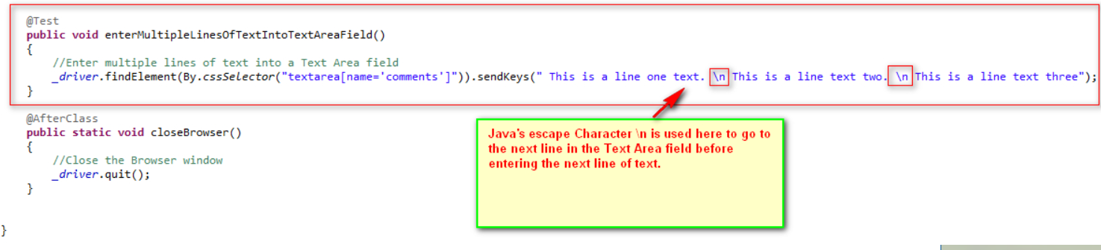

In the similar manner we can use the other Java escape characters like:

**\b** - backspace

**\t** -  tab

**\n** - newline

**\f** -  form feed

**\r** - carriage return

**\"** - double quote

**\'** -  single quote

**\\** - backslash

# UsingSendKeysToSelectOptionFromDropDownList

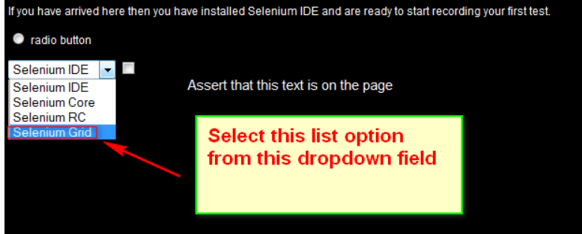

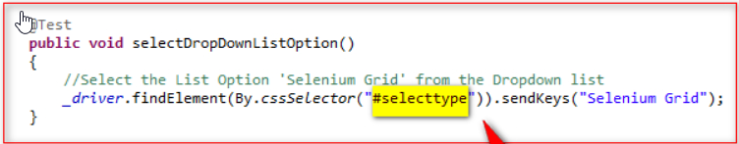

# selectByVisibleText()-Drop Down

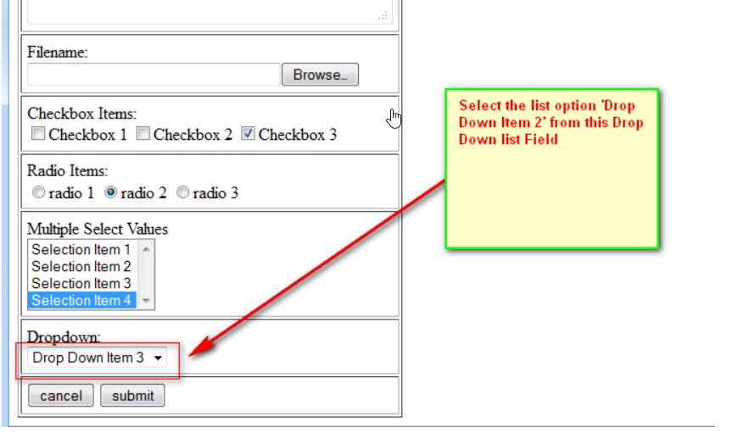

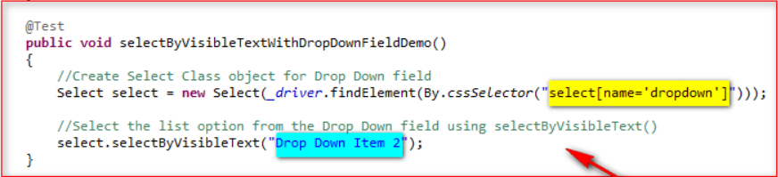

# selectByIndex

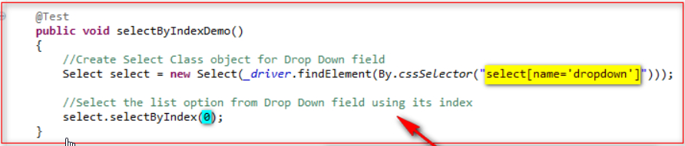

# SelectByValue

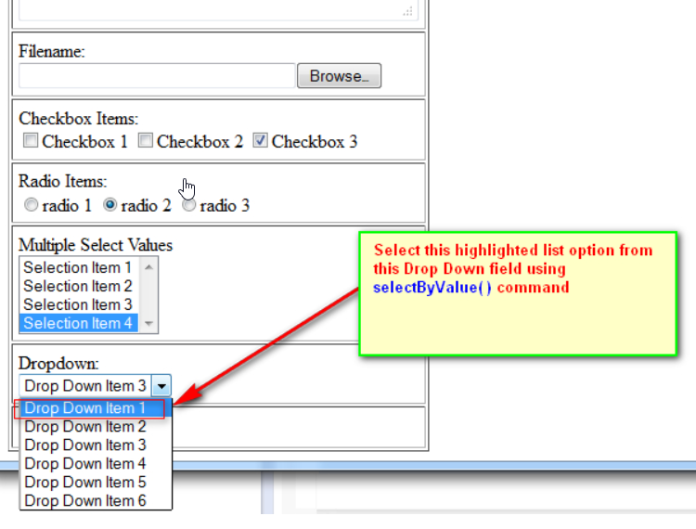

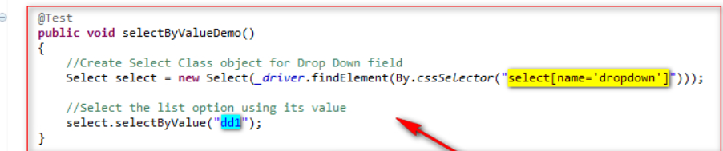

# Navigate().to()

We can also use **navigate( ).to( )** Selenium WebDriver method to open the specified URL page.  
  
**navigate( ).to( )** functions similar to **get( )** command. But **get( )**command is easy to type when compared to **navigate( ).to( )** command.

Driver.navigate().to(www.test.com.au)

# navigate( ).back( )

The only difference between get( ) and navigate( ) commands is we can go backward and forward on our browser using navigate( ) command only.  
  
In this post lets implement **navigate( ).back( )** command to navigate backward in our browser.  
  
*Syntax:*   **_driver.navigate( ).back( );**

# .navigate( ).forward( )

the only difference between get( ) and navigate( ) commands is we can go backward and forward on our browser using navigate( ) command only.  
  
In this post lets implement **navigate( ).forward( )** command to navigate forward in our browser.  
  
*Syntax:*   **_driver.navigate( ).forward( );**